HP MIK – Patch Assistant Updates to fix “No Data issue”

This document is primarily focused on guiding the user to fix the issue where the HPPA dashboard shows “No Data”. The issue is caused when HPPA deployment reporting classes override the HP MIK Client classes during machine policy retrieval due to conflicting namespace.
The correction steps in this document are only needed for the environments with the following symptoms of the HPPA Plugin.
- HP MIK 5.0.0.42729 is installed on the SCCM console.
- HPPA policy has been configured on at least one or more collections and successfully deployed to the clients.
- HPPA task has successfully run-on devices under the configured collections at least once.
- SCCM has completed the hardware inventory scan to pull the data from the client to the server since the last time the task ran.
- If one of the two scenarios is met:
  - The HPPA Dashboard is still showing devices as “No Data” even though there is a json report available under %ProgramData%/HP/MIK/HPIAReport on the client and the hardware inventory scan occurred after json report creation.
  - The HPPA Dashboard was showing the appropriate device reports. However, after some time, the same devices are being reported as “No Data”. Reinstallation of MIK Client fixes the issue temporality and the issue reappears again.

Steps to be executed on SCCM Console
Important note: These steps are required to be completed on the console before the installation of the latest MIK Client on your clients. If you already have an existing MIK Client on your clients, you are still required to complete these steps before upgrading MIK Client to the latest version.
- Install / Upgrade to HP MIK 5.1.1.47 or later on HP FTP.
- As a part of the installation, a script has been added that updates the reporting classes of any existing HPPA deployment as a part of the fix for the issue. To ensure that the script has successfully updated reporting classes, please navigate to the following path %ProgramData%\HP\HP MIK\Logs and open the log file “HP_MIK.InstallScript.log”. Ensure that there are no errors and that the log file has the following logs at the end of the script. If the logs are matching, please skip the next step.
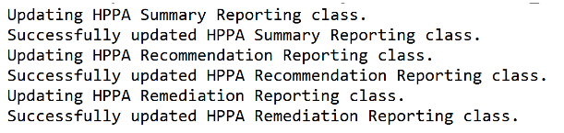
- If the script has not run successfully in the previous step, the IT Administrator needs to manually run the script. The script can be run through PowerShell or Command Prompt as administrator. Download the following two files and follow the instructions in HP_MIK_InstallScript_Instructions.txt
https://hpia.hpcloud.hp.com/downloads/doc/hpmik/HP_MIK_InstallScript_Instructions.txt
https://hpia.hpcloud.hp.com/downloads/doc/hpmik/HP_MIK_InstallScript.vbs.txt
Step 2: Force all HPPA clients to retrieve the machine policy
- In the SCCM console, navigate to Assets and Compliance > Overview > Device Collections. Right-click each HPPA configured collection, go to Client Notification, and select Download Computer Policy. This will force all online clients to retrieve the updated machine policy as we have updated the reporting classes of the deployment.

Important note
This step will only trigger machine policy retrieval on online clients. The offline clients will get the latest machine policy once they are online and reconnect to SCCM.
Before moving to step 3, the IT Administrator needs to ensure that enough time is given to their clients based on their SCCM configurations so clients can retrieve the updated machine policy to correct HPPA reporting classes on clients.
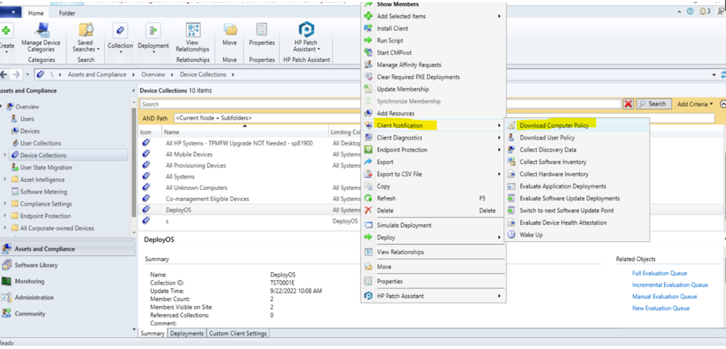
Track the Progress of Machine Policy and Retrieval
The IT Administrator can also follow the steps below to track the progress of the machine policy retrieval on their clients. It is recommended to follow these steps as they will help to confirm the effectiveness of the previous step.
- In the SCCM console, navigate to Monitoring > Overview > Queries. Right-click the node and select “Create Query”.
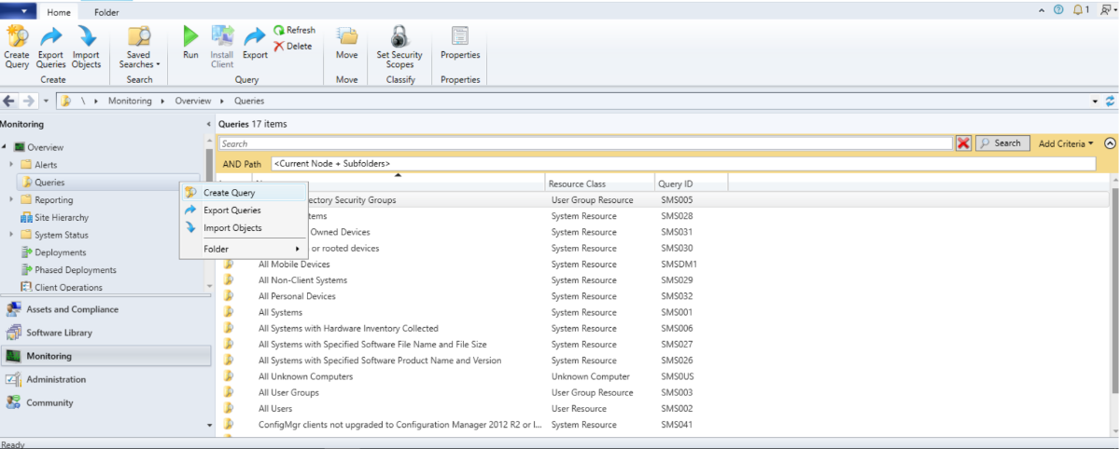

- In the Create Query Wizard, name the query Systems – HPPA – Requesting Policy after <date> and click “Edit Query Statement”.
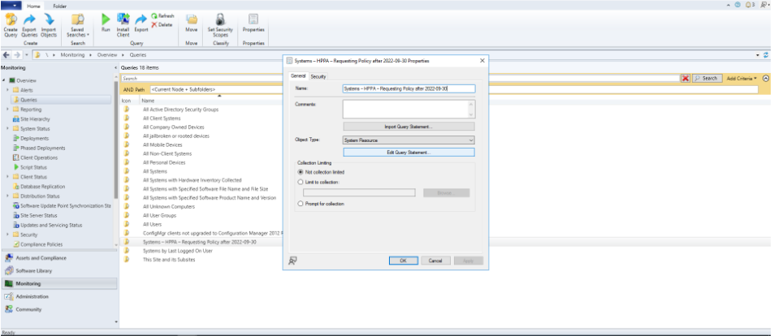
- In the Properties pop-up, click “Show Query Language” and paste the following query in the pop-up and click OK. Then, click OK, Next, Next, and Close.
Please update the date in this query as needed. The date should be when the new HP MIK is installed.
Format of date: YYYYMMDD

Query:
SELECT Client.LastPolicyRequest, R.Name, R.ResourceID from SMS_R_System as R INNER JOIN SMS_G_System_CH_ClientSummary Client on Client.ResourceID = R.ResourceId INNER JOIN SMS_FullCollectionMembership collection ON collection.ResourceID = R.ResourceID WHERE collection.IsClient='1' AND collection.CollectionID IN (SELECT DISTINCT BA.TargetCollectionID FROM SMS_BaselineAssignment BA INNER JOIN SMS_ConfigurationItemLatest CBL ON BA.AssignedCI_UniqueID = CBL.CI_UniqueID INNER JOIN SMS_ConfigurationItemLatest CIL ON CBL.LocalizedDisplayName = CIL.LocalizedDisplayName INNER JOIN SMS_ConfigurationItemRules R ON CIL.CI_ID = R.CI_ID WHERE CIL.LocalizedDisplayName like 'HPPA%' AND CIL.CIType_ID = 5 AND CBL.CIType_ID = 2 AND CIL.RuleName = 'Task Enable') AND Client.LastPolicyRequest > '20220930'

Important Note
The date above needs to be updated properly to when policy retrieval is forced. The goal is to check if all HP clients managed by HPPA policies have retrieved machine policy before moving on to the next step.
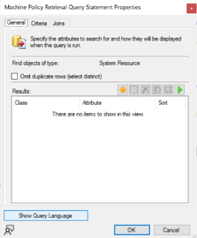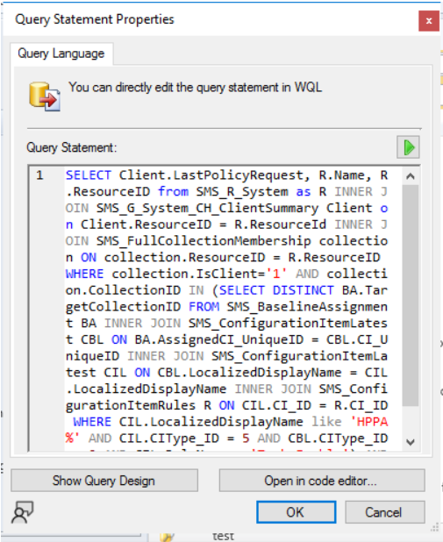

- The newly created query will be shown under the “Queries”. Right-click the newly created query and select Run to run the query and see the results.
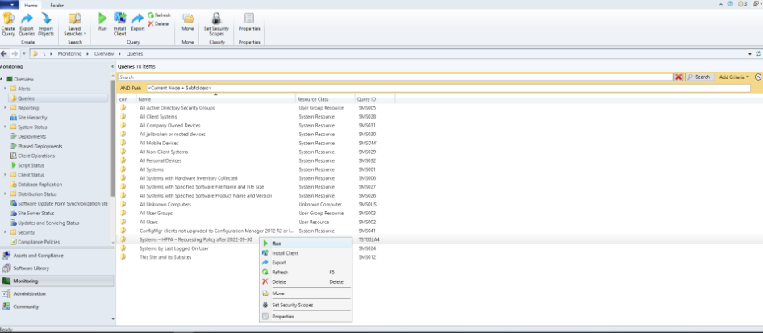

Steps on managed device
Optional Step:
The following is an example of a client which has an existing MIK Client installed with overridden HPPA classes. This is an optional step and just additional information for the administrator who would like to confirm the state of their client before installing/upgrading the MIK Client.
- On the windows search bar, type wbemtest and run the application as administrator.

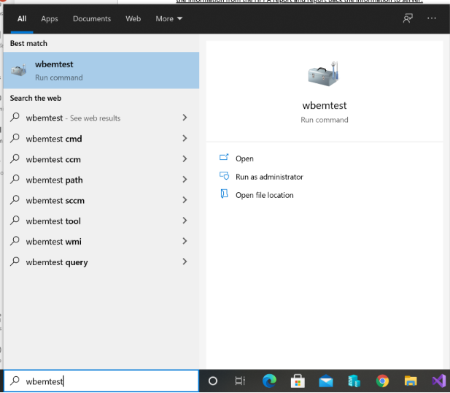

- Click the connect button.

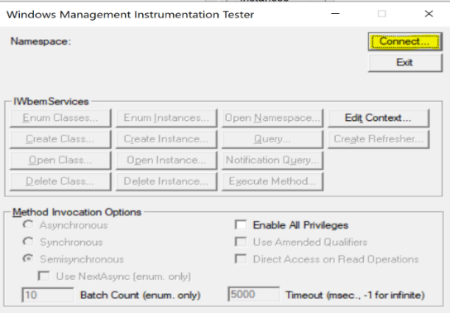
- Enter the following in the namespace field and click Connect.
ROOT\HP\InstrumentedServices\v1

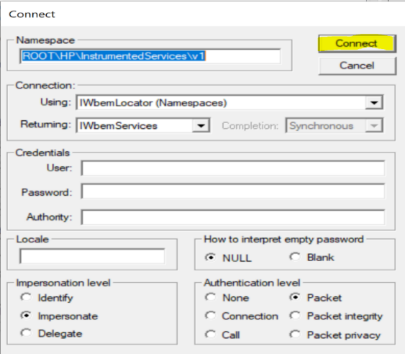

- Click on Enum Classes, then select recursive and click ok.

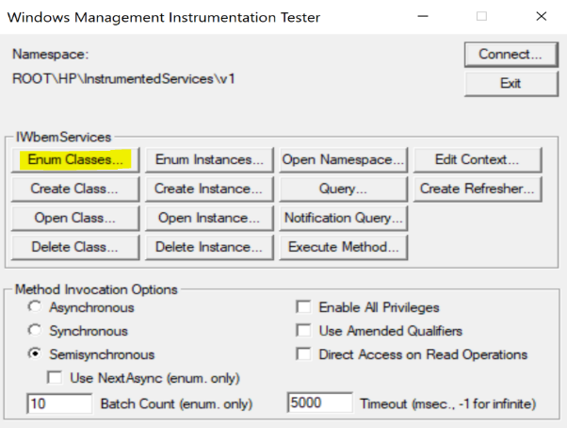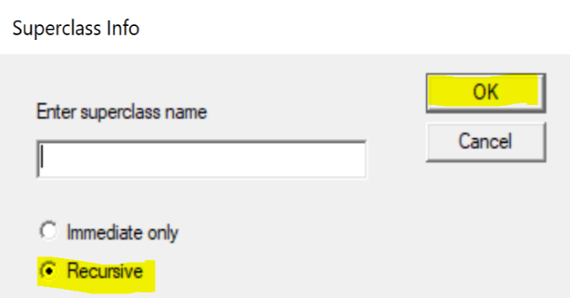
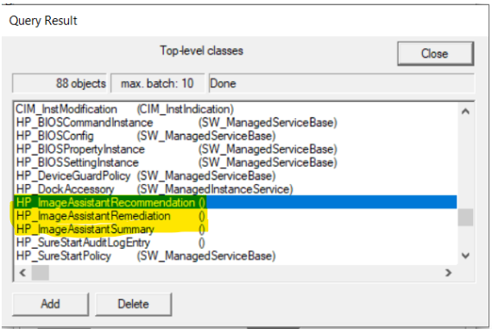

Step 3: Installation / Upgrade of MIK Client.
- Install / Upgrade to HP MIK Client 5.1.1.37 or later on HP FTP. This step will fix the corrupted HPPA classes on the client which allows the provider to populate data from the HPIA Report.

After installation/upgrade of MIK Client, the snapshot above from the optional step should update to the following where SW_ManagedInstanceService is now shown correctly compared with the previous snapshot where 0 is shown.
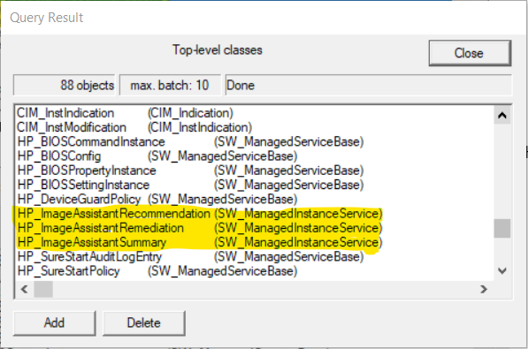

Track progress of installation of MIK Client
Create another new query by following the steps of Track the Progress of Machine Policy and Retrieval and name the query Systems with HP MIK Client <version> and paste the following query in the “Show Query Language” pop-up. This query returns all clients that have MIK Client installed with a specific version. Please update the version in this query as needed.
Query:
SELECT DISTINCT R.Name, SMS_G_System_ADD_REMOVE_PROGRAMS.DisplayName, SMS_G_System_ADD_REMOVE_PROGRAMS.Version FROM SMS_R_System AS R INNER JOIN SMS_G_System_ADD_REMOVE_PROGRAMS on SMS_G_System_ADD_REMOVE_PROGRAMS.ResourceId = R.ResourceId WHERE SMS_G_System_ADD_REMOVE_PROGRAMS.DisplayName = 'HP MIK Client' AND SMS_G_System_ADD_REMOVE_PROGRAMS.Version = '5.1.1.37'
Step 4: Retrigger Machine Policy and Retrieval.
- Repeat Step 2: Force all HPPA clients to retrieve the machine policy. This step will ensure that the issue has been resolved correctly before we collect hardware inventory information from the clients in the next step.
On the next hardware inventory scan of online and connected clients, the appropriate client data will be sent to the SCCM console and the HPPA dashboard should reflect the clients’ data. Optionally, the IT Administrator can also force the hardware inventory scan (as shown in the next step) to verify the fix without waiting for the SCCM hardware inventory schedule.

Important note: The providers will only read the data from the json file on the client if the scheduled task has run at least once and has generated the json file. If the task has not ran at least once, then the client will still report as “No Data” on the HPPA dashboard because there is nothing to report back to the server from the client. This machine is expected to be under “No Data” category.
Step 5: Trigger Hardware Inventory
- In the SCCM console, navigate to Assets and Compliance > Overview > Device Collections. Right-click each HPPA configured collection, go to Client Notification and select Collect Hardware Inventory. This will force a hardware inventory scan on online and connected clients.
Import note: This step will only trigger hardware inventory scan on online clients. The offline clients will not report any hardware inventory information back to the console.

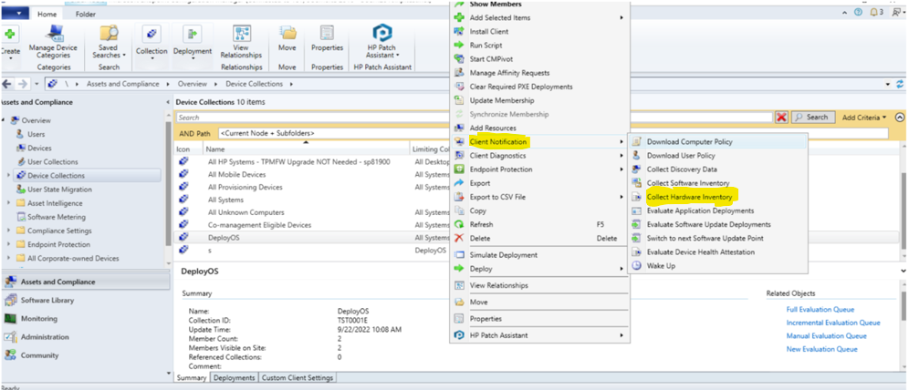

Track progress of installation of Hardware Inventory Scan
Create another new query by following the steps of Track the Progress of Machine Policy and Retrieval, name the query as Systems – Requesting HW Scan after <date>, and paste the following query in the “Show Query Language” pop-up. This query returns all clients on which the hardware inventory scan was completed after a given date. Please update the date in this query as needed.
Format of date: YYYYMMDD
Query:
select s.ResourceId, s.NetBiosName from SMS_R_SYSTEM s inner join SMS_G_System_WORKSTATION_STATUS ws on s.ResourceId = ws.ResourceId
where ws.LastHardwareScan >= '20220930'
Important Note
The date in the query above must be changed to when hardware inventory scan is forced to
check if expected clients have reported hardware inventory data which includes HPPA data.
Evaluation
After the completion of the previous step, if most of the clients still report as “No Data”, please ensure the following for those clients:
- HPPA task has successfully ran on those clients and a json report is generated.
- HPIA did not report any errors in the generated json report.
- Hardware inventory scan was triggered and completed after the generation of json report.
If all of the prerequisites above are checked and the issue is still not resolved, please repeat the steps from Step 2: Force all HPPA clients to retrieve the machine policy.

